Student Id – IT24100800

Name – Rajapaksha A.G.S

Lab sheet 10

1

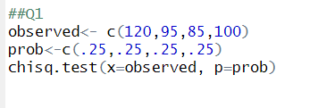

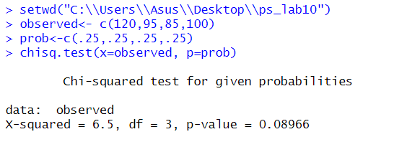

2

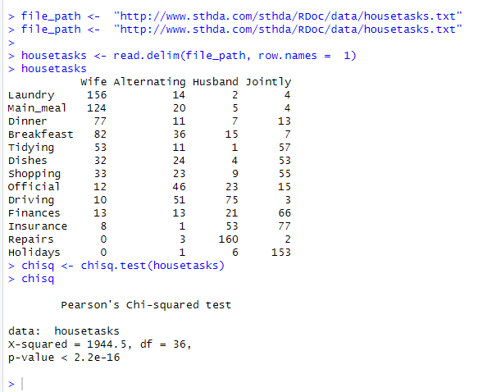

3

